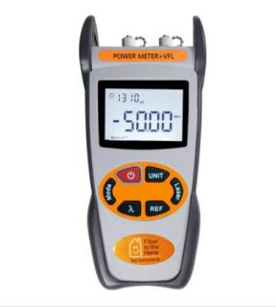

Power meter +VFL S403

Features

Power meter and VFL integrated in one unit, this tester allows to perform both optical power/loss measurements and fiber faults tracing visually.

S403 power meter + VFL is an ideal tester used in quickly mechanical splicing and FTTx networks.

Specifications
Type | S403
Operating wavelength  (Power Meter Module) | 1310, 1490, 1550, 850, 1300, 1625
Detector Type | InGaAs
Output power (VFL module) | 1mw (according to the customer’s requirements)
Power Measurement Range | -70~+6dBm
Uncertainty | ±0.5dB
Resolution | 0.01
Operation Temperature | -10~+60 ℃
Storage Temperature | -25~+70 ℃
Auto-off function | Yes, Auto-off after 10minutes idle time
Battery Life @ OPM | 240 hours
Battery Life @ VFL | 60 hours (1mw)
Power Supply | 3pcs AA Batteries
Weight(g) | 285
Size(mm) | 200 X90 X50

​

