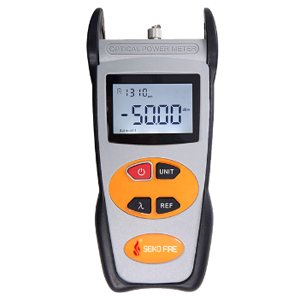
Power Meter S305
This optical power meter series is a compact and an easy-to-use testing instrument for optical fiber networks, which can be used for absolute optical power measurements as well as for relative loss measurements in optical fibers. It has features of ingenious appearance, wide range of power measurement, high accuracy with high performance-to-price ratio.
Features
Comfortable LCD display and optional backlight LCD display supports night operation;
Power measurements in dBm or mw and insertion loss in dB;
Reference power level storage (Ref Setting)
Low battery consumption, more than 240 hours continual operation time with three 1.5V alkaline batteries;
10 minutes Auto-off function can be activated or deactivated.
Applications
Maintenance in Telecom
Maintenance in CATV
Fiber Optic Lab Testing
Other Fiber Optic Measurements
Specifications
Wavelength(nm) | 800~1700nm
Detector | InGaAs
Measurement Range (dBm) | -70~+3 | -50~+26
Uncertainty | ±5%
Calibrated Wavelength(nm) | 850,1300,1310,1490,1550,1625
Resolution(dB) | 0.01
Optical Connector | FC(interchangeable SC,ST) / as well as 2.5mm universal
Power Supply | Alkaline Battery(3 AA 1.5V batteries)
Battery Operating Time | 240 h with 1.5V Battery(3)
Operating Temperature(℃) | -10 ~ +60
Storage Temperature(℃) | -25 ~ +70
Relative Humidity | 0 to 95% (non-condensing)
Dimension(mm) | 200 X90 X50
Weight(g) | 285

