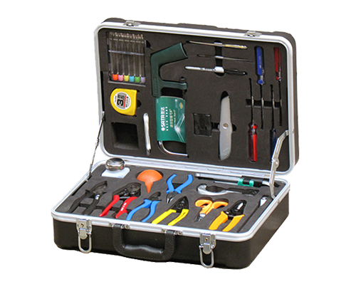
Fiber Optic Tool Kits S26
The S26 tool kits is suitable for optical fiber fusion splicing. It includes all the most frequently needful tools and supplies required for cable sheath removal and fusion splicing.
Specifications
NO. | ITEM | NO. | ITEM
1 | Fiber optic stripper CFS-2 | 14 | 9Pcs Folding type hex key set (inch)
2 | KEVLAR Scissor | 15 | Screwdriver S/D (-)5×100mm
3 | Fiber Jacket Stripper | 16 | Screwdriver S/D (+) #1×100mm
4 | Longitudinal Buffer Tube Slitter | 17 | Screwdriver S/D (-)6×100mm
5 | Steel Wire Rope Cutter | 18 | Screwdriver S/D (+) #2×100mm
6 | Round Cable Cutter | 19 | 4 oz. Bottle of Alcohol
7 | Carbide fiber scribe | 20 | Cotton Swabs CS-1 (25pcs/bag)
8 | 6Pcs Electronic Screwdriver Set | 21 | Blow Brush
9 | 7'' Lineman's pliers 178mm | 22 | Utility knife
10 | 6'' Needle Node Pliers 135mm | 23 | 3.5M Tape Measure
11 | 6'' Side Cut Pliers 130mm | 24 | Precision tweezers
12 | 8" Adjustable wrench | 25 | Black Marker
13 | Mini-Hacksaw | 26 | Carrying Tool Case(430×330×135mm)

