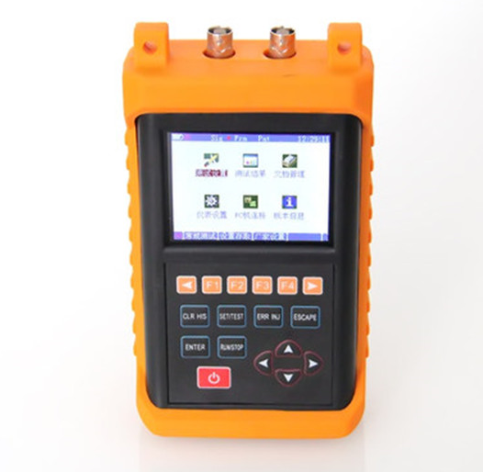
S1200 Data Transmission Analyzer
Overview
S1200 Data Transmission Analyzer, the latest tester developed by Seiko Fire, is the necessary tools for daily maintenance, troubleshooting and equipment installation and maintenance. It can be for 2M on-line monitoring as well as test from 50b/s to 2048kb/s with supported interfaces like G.703, V.24/RS232, V.35, V.36/RS449, X.21, EIA－530/530A and RS485/RS422. It also supports 2M jitter TX/RX test, 2M synchronous clock test and frame relay test.
The S1200 is configured with large screen TFT color LCD with backlighting and built-in rechargeable Li battery for more than 8 hours’ working without external power supply. S1200 also supports RJ45 network interface and complete TCP/IP protocol with on-line upgrading.
This product is suitable for high-end applications like operators’ 2M equipment maintenance and overhaul and frame relay test of telecom VIP.
Functions
G.703 E1 in-service / out of service Test
Dual E1 ports monitoring
Various alarming types and BER types insert
Balance interface (75Ohm) / unbalanced interfaces(120Ohm)
ITU-T G.821/G.826/M2100/2101 BER Analysis
Slips analysis
Clock slip
Clock frequency offset test
NX64K Test
Frame Setting/ Analysis
PCM / time slot detection
Time slot data display
Histogram display
Voice monitoring
Auto test
Loopback delay test
Switching time test
Audio Test (Optional)
Pulse mask measurement (optional)
E1 jitter Rx/Tx test (Optional)
E1 synchronous clock test (Optional)
V interface test (optional)
V.24/RS232, V.35, V.36/RS449, EIA-530/530A, X.21 interface BER tests
Various working mode setting
ITU BER index analysis
PING test
IP address setting
Ethernet connectivity test
Frame Relay Test (Optional)
Support E1, V.35 Port
Support PPP/HDLC Protocol
Features
Color TFT LCD with touch screen
Dual E1 Test
2M synchronous clock input/output
2M clock jitter Rx/Tx test
2M PING test
Frame relay test
PC can perform remote control for tester through Ethernet
Large capacity Li battery guarantees more than 8 hours’ working without external
Power supply
Large capacity digital storage
Applications
Out of service loopback Test
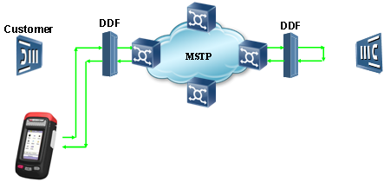
Out of service end-to-end Test
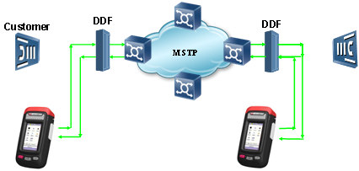
In-service Test
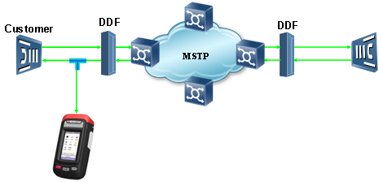
Throughput Test
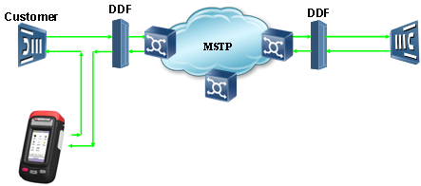
V Interface Test (Optional)
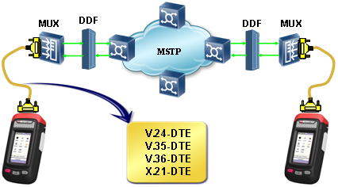
Audio Test (Optional)
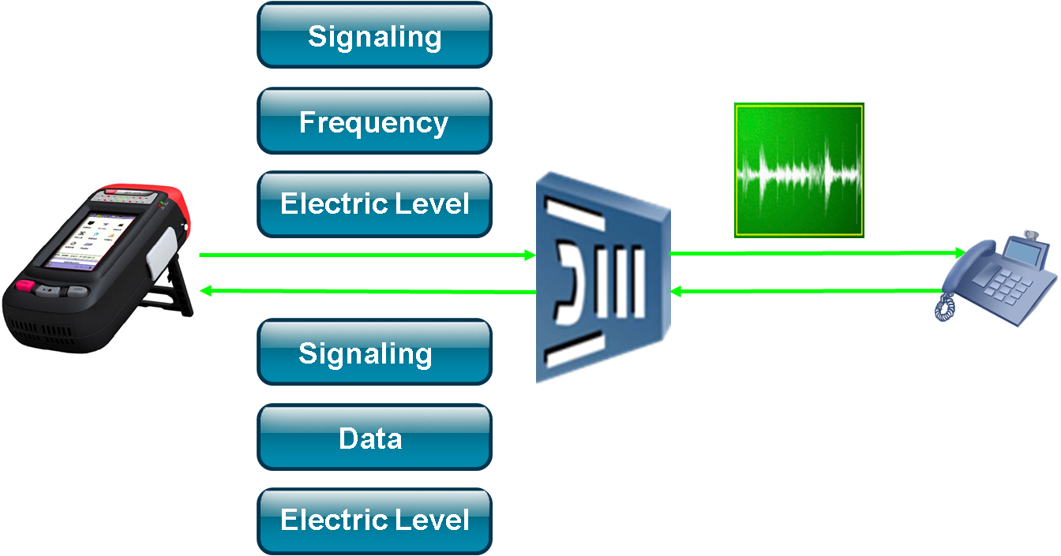
E1 Signal Template (Optional)
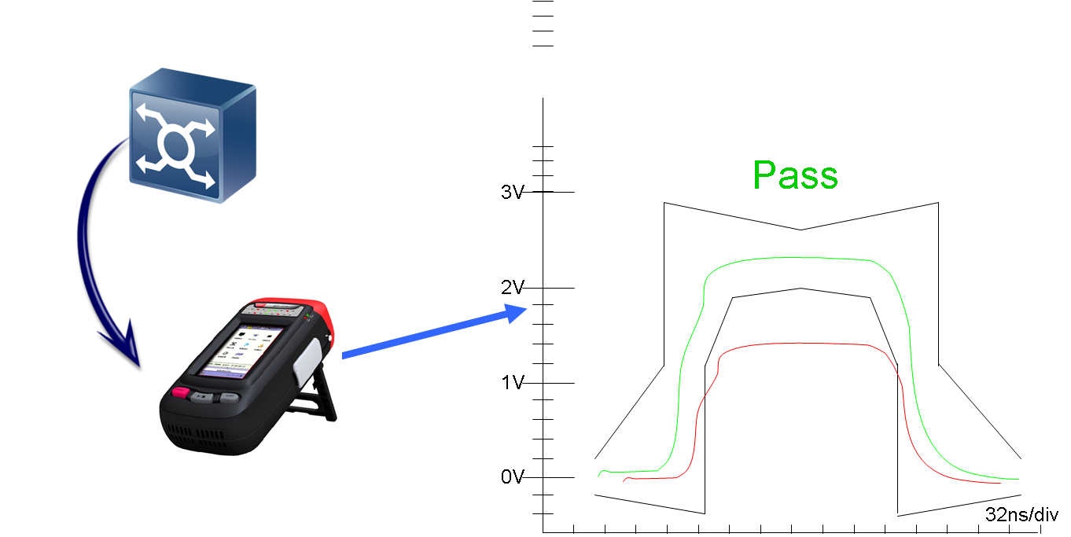
Jitter Test (Optional)
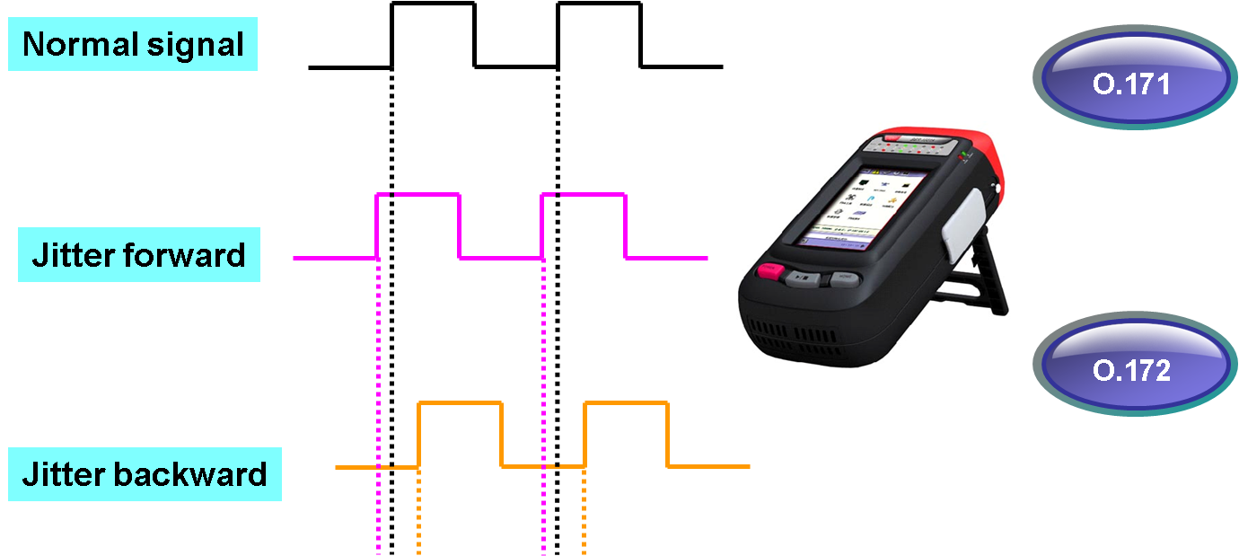
Frame Relay Test (Optional)
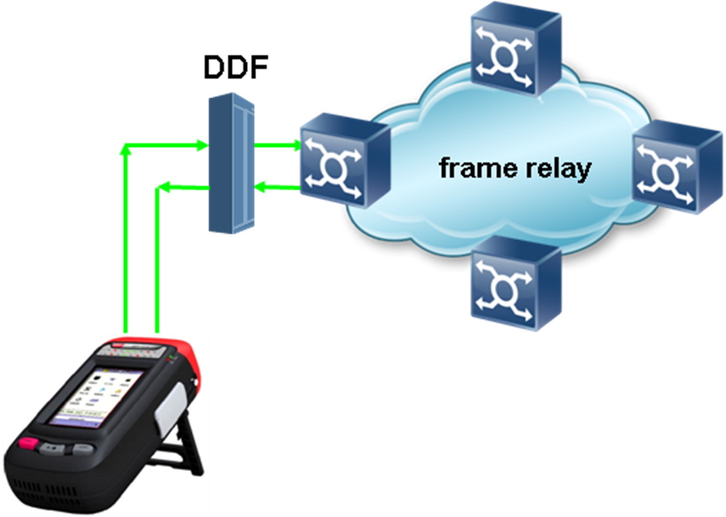
Specifications
General Specifications
Size |  | 210×110×60（mm）
Weight |  | 1.2kg
Display screen |  | Color 4.3”LED，480×272，LED BL
Operation mode |  | Touch screen
Management interface |  | RJ45(10M/100M)、USB
Power supply |  | AC adapter:100V/240V，50/60H/z
Battery |  | Rechargeable 4400mAh Li battery
Endurance time |  | 8 hours
Operation environment | Operation Temperature | 0℃~+50℃
Operation environment | Storage Temperature | -20℃~+70℃
Operation environment | Operation Humidity | 10% ~ 90%
Operation environment | Storage Humidity | 5% ~ 95%

Ordering Configurations
Standard Configurations & Accessories
Host | Accessories | Quantity
S1200 Data Transmission Analyzer | Li Battery | 1
S1200 Data Transmission Analyzer | User manual | 1
S1200 Data Transmission Analyzer | 0.5m BNC self-test Cable | 1
S1200 Data Transmission Analyzer | 2.5m BNC test Cable | 1
S1200 Data Transmission Analyzer | 2.0m Ethernet crossed Cable | 1
S1200 Data Transmission Analyzer | 2.5m Test line of alligator clip | 1
S1200 Data Transmission Analyzer | Power adapter (2.0A) | 1
S1200 Data Transmission Analyzer | Instrument bag (including braces)
S1200 Data Transmission Analyzer | Management platform CD | 1
S1200 Data Transmission Analyzer | L9-J Plug (75-1-1) | 1
S1200 Data Transmission Analyzer | BNC-J Plug (75-1-1) | 1

Optional Configurations
Serial No. | Function
1200-01 | E1Audio Test
1200-02 | E1 Eye Diagram
1200-03 | T1 Interface anomaly and defect test
1200-04 | T1 Eye Mask
1200-05 | V Interface anomaly and defect test
1200-06 | E1 Clock synchronization test
1200-07 | E1Jitter Rx/Tx Test
1200-08 | Frame Relay Test

