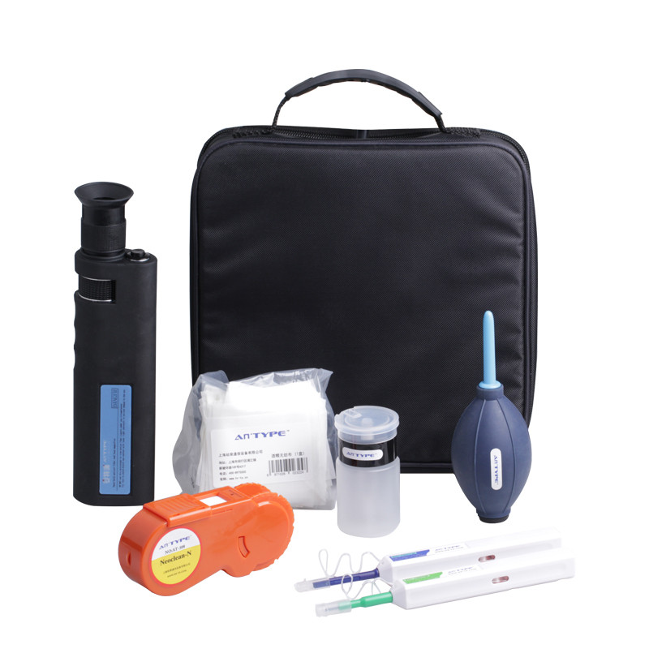
Fiber Optic Cleaning Kit FTTH Tool Kit S12

Fiber Optic Cleaning Kit is ideal for fiber optic connector cleaning.
We provide a range of tool kits for cabling instruction, such as the FTTH Quick Termination kits, Fiber Optic Cleaning Kits, Fiber Optic Fusion Splicing tool kits, Fiber Testing Kits with high quality and fast delivery.
We can also OEM the Fiber Optic Tool Kits according to customers requirement.

Fiber Optic Cleaning Kit Includes
Fiber Optic Cassette Cleaner.
400X Hand Held Fiber Microscope.
Ergonomic One-Click Cleaner (SC/ST/FC).
Ergonomic One-Click Cleaner (LC/MU).
Fiber Optic Cleaning Wipes.
Alcohol Bottle.
Blow Brush.
Carrying Tool Bag.

