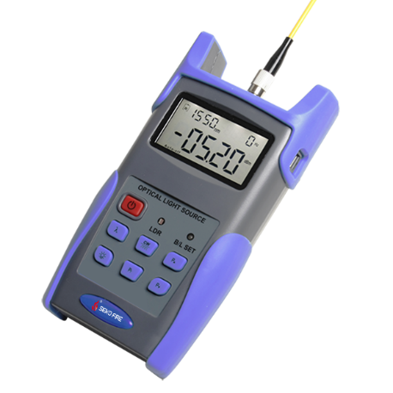
Light Source S106
S106 handheld adjustable light source is Seikofire newly designed fiber optic tester, it aims at fiber network installation, fiber network engineering acceptance and fiber network maintenance. Combined usage with S308 handheld optical power meter, it offers a quick and accurate testing solution on both SM and MM fibers. The S106 provides 1 to 4 wavelengths and output power can be adjustable on customer requests. Also, the S106 features good appearance, good touch feeling and considerate humanity design.
Features
Wave ID information can be transmitted when used with S308 Optical Power Meter.
Tone generation, 270HZ,330HZ,1KHZ,2KHZ
Output power can be adjustable
Output power value is shown on LCD display
Intelligent backlight control (light intensity can be adjusted properly according to ambient light, which greatly reduced power consumption)
AA alkaline and AC adapter for power supply
Low battery indication
Applications
Maintenance in Telecom
Maintenance CATV
Fiber Optic Lab Testing
Other Fiber Optic Measurements
Specifications
Model | S106
Operating wavelength (nm) | 1310/1550;1310/1490/1550/1625 (others specify on requests)
Applicable fiber | SM, MM
Laser type | FP-LD (others specify on requests)
Output Power (dBm) | -7(can be adjustable)
Adjustable step size (dBm) | ＜0.5
Stability (dB, 30min, 20℃) | 0.15
Modulation (Hz) | CW, 270, 330, 1K, 2K
Fiber Port | FC/PC
Alkaline Battery | 3*AA, 1.5V
Power Supply Adaptor (V) | 8.4
Battery Operating time (h) | 45
Operation Temperature (℃) | -10～+60
Storage Temperature (℃) | -25～+70
Outline size (mm)/weight | 180*90*45/(250g)
Standard Package
S106 optical light source
3pcs 1.5V batteries
AC adaptor
User manual
Cotton swabs and soft carrying case

