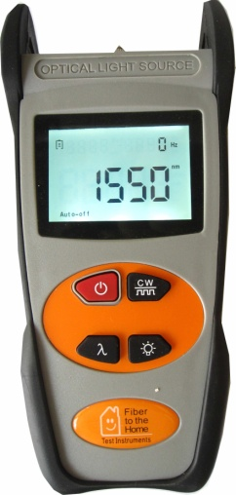
Light Source S102
Optical light source is one of the latest self developed test instrument. It can provide 2 to 5 wavelength output according to the specific requirements including the 650nm red source, 1310/1550nm wavelength for the single mode fiber and 850/1300nm wavelength for the multimode fiber or other wavelengths according to customer needs. Together with optical power meter, it acts as a perfect solution for the fiber optic network work.
Features
Tone generation, 270HZ, 1KHZ, 2KHZ;
Output power value is shown on LCD display;
Intelligent backlight control (light intensity can be adjusted properly
According to ambient light, which greatly reduced power consumption);
AA alkaline for power supply;
Low battery indication.
Specifications
Operating wavelength(nm) | 1310/1550 (others specify on requests; Max wavelength is 5)
Applicable fiber | SM, MM
Laser type | FP-LD (others specify on requests)
Maximum Output Power(dBm) | -7(can be adjustable, others specify)
Stability (dB, 15min, 20℃) | ±0.1
Stability (dB, 30min, 20℃) | ±0.05
Modulation (Hz) | CW, 270, 1K, 2K
Fiber Port | FC/PC or FC, SC, ST interchangeable
Alkaline Battery | 3XAA, 1.5V
Battery Operating time(h) | 45
Operation Temperature (℃) | -10～+60
Storage Temperature (℃) | -25～+70
Outline size（mm） | 200 X90 X50
Weight(g) | 285

