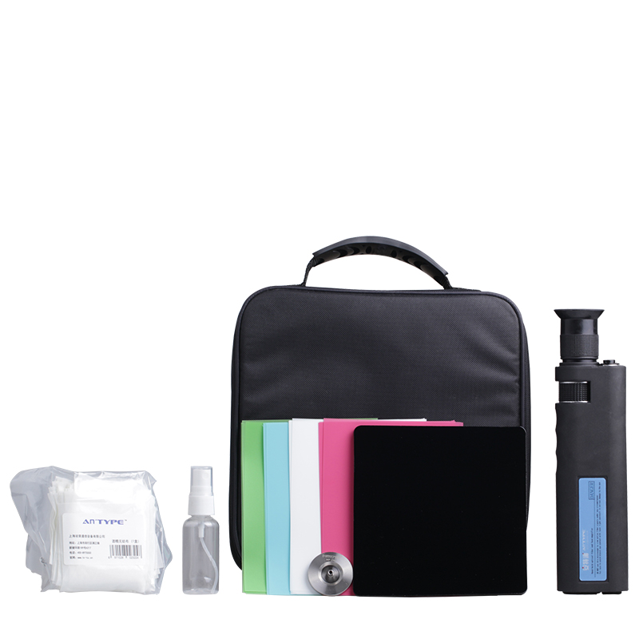
Fiber Optic Cleaning Kit FTTH Tool Kit S10

Fiber Optic Cleaning Kit is ideal for fiber optic connector cleaning.
We provide a range of tool kits for cabling instruction, such as the FTTH Quick Termination kits, Fiber Optic Cleaning Kits, Fiber Optic Fusion Splicing tool kits, Fiber Testing Kits with high quality and fast delivery.
We can also OEM the Fiber Optic Tool Kits according to customers requirement.

Fiber Optic Cleaning Kit includes
400X Hand Held Fiber Microscope.
30µm Polish Film -5sheets.
9µm Polish Film -5sheets.
1µm Polish Film -5sheets.
0.05µm Polish Film -5sheets.
2.5mm Universal Polish Puck.
Rubber Polish Pad.
Fiber Optic Cleaning Wipes.
Dispensing Bottle.
Carrying Tool Bag.

