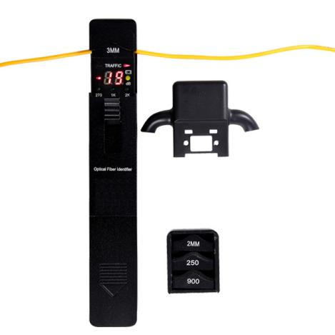
Fiber Identifier S505
Optical Fiber Identifier can quickly identify the direction of transmitted fiber and display the relative core power without interrupting the current service. The fiber identifier recognizes modulation like, 270Hz,1KHz and 2KHz with continuous audible tone. There are four adapter heads available: Ø0.25, Ø0.9, Ø2.0 and Ø3.0. This OFI is powered by 2pcs very normal AA batteries.
Features
Easy-to-use with “ONE KEY” operation
Efficiently identifies the fiber transmission direction and frequency tone (270Hz, 1KHz, 2KHz) with audible warning
Displays the relative core power
Easy-to-replace adaptor
Durable metal housing and quality construction
Lower power indication
It's easy to carry and loss adaptor can be avoided with new adaptor box
Specifications
Identified Wavelength Range | 800-1700 nm
Identified Signal Type | CW, 270Hz±5%，1kHz±5%，2kHz±5%
Detector Type | Ø1mm InGaAs 2pcs
Adapter Type | Ø0.25, Ø0.9, Ø2.0, Ø3.0
Signal Direction | Left & Right LED
Singe Direction Test Range  (dBm, CW/0.9mm bare fiber) | -46~10(1310nm)
 | -50~10(1550nm)
Signal Power Test Range  (dBm, CW/0.9mm bare fiber) | -50~+10
Signal Frequency Display (Hz) | 270, 1k, 2k
Frequency Test Range  (dBm, Average Value) | Ø0.9, Ø2.0, Ø3.0 | -30~0 (270Hz,1KHz)
 |  | -25~0 (2KHz)
 | Ø0.25 | -25~0 (1KHz,2KHz)
 |  | -20~0 (2KHz)
Insertion Loss (dB, Typical Value) | 0.8 (1310nm)
 | 2.5 (1550nm)
Alkaline Battery(V) | 2pcs AAA batteries
Operating Temperature (℃) | -10－+60
Storage Temperature (℃) | -25－+70
Dimension(mm) | 196x30.5x27
Weight(g) | 195

